Resolution GUMS 22-04 Replacement - Amendment A
CORPORATE RESOLUTION TO RECOMMEND NEW DIRECTOR OF GOODWIN UNIVERSITY MAGNET SCHOOLS, INC
The Undersigned Secretary of Goodwin College Magnet Schools, Inc. hereby certifies that the following resolution was duly adopted by the Board of Directors on May 3, 2022, and that such resolution has not been modified or rescinded as of the date hereof:
WHEREAS, in accordance with the Corporate Bylaws of Goodwin University Educational Services, Inc., the Goodwin University Educational Services (GUES) Board shall appoint all Directors of Goodwin University Magnet Schools Inc. and
NOW THEREFORE, BE IT
RESOLVED, the Goodwin University Magnet School Board would like to recommend to the Goodwin University Educational Services Board, the appointment of Lee Housley, a current member of the GUES Board to serve as a Director on the GUMS Board, with a term in accordance with the GUES Bylaws

Signed: 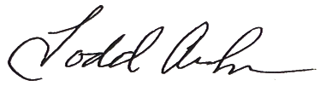 Signed: 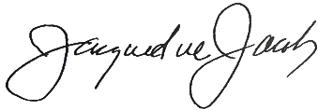

Todd Andrews, Secretary Jacqueline Jacoby, Chair
Goodwin University Magnet School, Inc. Goodwin University Magnet School, Inc.

Date: _5/3/22 Date: 5/3/22

