Resolution GUMS 22-03

CORPORATE RESOLUTION APPROVE THE 2022-23 GOODWIN UNIVERSITY MAGNET SCHOOLS, INC ACADEMIC CALENDAR

The Undersigned Secretary of Goodwin University Magnet Schools, Inc. hereby certifies that the following resolution was duly adopted by the Board of Directors on May 3, 2022, and that such resolution has not been modified or rescinded as of the date hereof:

WHEREAS, Goodwin University Magnet Schools, Inc. to approve the 2022-23 Academic Calendar pending approval from LEARN.

NOW THEREFORE, BE IT

RESOLVED, that Goodwin University Magnet Schools, Inc. Board approve the 2022-23 Academic Calendar pending approval from LEARN.

Signed: Signed:
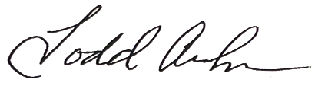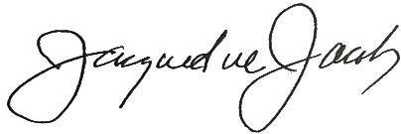
Todd Andrews, Secretary Jacqueline Jacoby, Chair
Goodwin University Magnet Schools, Inc. Goodwin University Magnet Schools, Inc.

Date: _5/3/22 Date: 5/3/22

