GOODWIN UNIVERSITY EDUCATIONAL SERVICES, INC.
Resolution of the Board of Directors
September 21, 2022

GUES Resolution 22-04
CORPORATE RESOLUTION TO ELECT DIRECTORS OF GOODWIN UNIVERSITY MAGNET SCHOOLS, INC.
The Undersigned Secretary of Goodwin University Educational Services, Inc. hereby certifies that the following resolution was duly adopted by the Board of Directors on September 21, 2022, and that such resolution has not been modified or rescinded as of the date hereof:
WHEREAS, in accordance with the Corporate Bylaws of Goodwin University Magnet Schools, Inc., its sole member, Goodwin University Educational Services, Inc. may elect at each annual meeting from two (2) to twelve (12) directors who shall each serve a term of one year
NOW THEREFORE, BE IT
RESOLVED, that the following are elected to serve as Directors of Goodwin University Magnet Schools, Inc. and shall have qualified:

Name
Merilee DeJohn
Jackie Jacoby
Megan Mehr
Lee Housley

Signed: 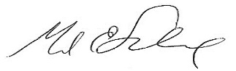 Signed:_ 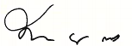
Mark E. Scheinberg, Secretary Maria Ellis, M.D., Chair

Date: 9/21/.2022 Date: 9/21/2022

