Resolution GUMS 22-02
CORPORATE RESOLUTION TO APPROVE THE 2022-23 GOODWIN MAGNET SCHOOL SYSTEM BUDGET
The Undersigned Secretary of Goodwin University Magnet Schools (GUMS), Inc. hereby certifies that the following resolution was duly adopted by the Board or Directors on May 3, 2022 and that such resolution has not been modified or rescinded as of the date hereof:
WHEREAS, Goodwin University Magnet Schools, Inc. has entered into an agreement with Goodwin University Educational Services, Inc. to authorize Goodwin University Magner Schools, Inc. to administer the budget and the operations of the magnet school, and
WHEREAS, a budget represented as Attachment A to this resolution has been prepared for the operation of the Goodwin University Magnet Schools, Inc. covering the period of July 1, 2022 through June 30, 2023, and
WHEREAS, the total anticipated budget for this period is $19,512,563 and
WHEREAS, grant funding from the state of Connecticut Department of Education of Inter district Magnet School Funds is available, and
WHEREAS, additional revenues for the operation of the school is available through the charging of tuition to local school districts from which attending students reside, and
WHEREAS, Goodwin University Magnet Schools, Inc., has entered into an agreement with Goodwin University Inc. to provide services to support the operation of the school and to represent Goodwin University Magnet Schools, Inc. functions;
NOW, THEREFORE, BE IT
Resolved that Goodwin University Magnet Schools, Inc. Board of Directors hereby approves the 2022-23 budget in an amount of $19,512,563 for the Goodwin University Magnet Schools, Inc. and be it further
RESOLVED, that Goodwin University Magnet Schools, Inc. Board of Directors hereby approves any further adjustments to such approved budget if necessary to stay within available appropriations, and it be further
RESOLVED, that the Goodwin University Magnet Schools, Inc. Board of Directors authorizes the President of GUMS and the Executive Director at LEARN, as its designated agent, to invoice and collect tuitions from the local school districts, and be it further
RESOLVED, that Goodwin University Magnet Schools, Inc. Superintendent is authorized to implement such budget for the operation of Goodwin Magnet Schools, Inc. which included the procurement of goods and services required for the operation of Goodwin University Magnet Schools.

Signed: Signed:
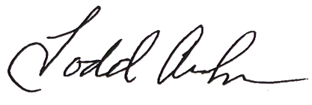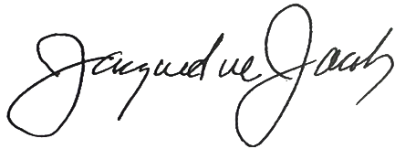
Todd Andrews, Secretary Jacqueline Jacoby, Chair
Goodwin University Magnet Schools, Inc. Goodwin University Magnet Schools, Inc.

Date: 5/3/22 Date: 5/3/22

